**Charting the course of innovation : A startup analysis**

**1.Introduction**

**1.1.overview**

**Starting a new company can be an exciting and rewarding experience, but it also requires careful planning and analysis to ensure that the business is viable and successful. There are several key areas that you should focus on when conducting a startup company analysis**

**1.2 purpose**

**Conducting a thorough analysis of these areas can help you identify potential challenges and opportunities, and develop strategies to address them. It is also important to regularly review and update your analysis as the business progresses, in order to adapt to changing market conditions.**

**2.Problem definition and design thinking**

**2.1 .Empathy map:**

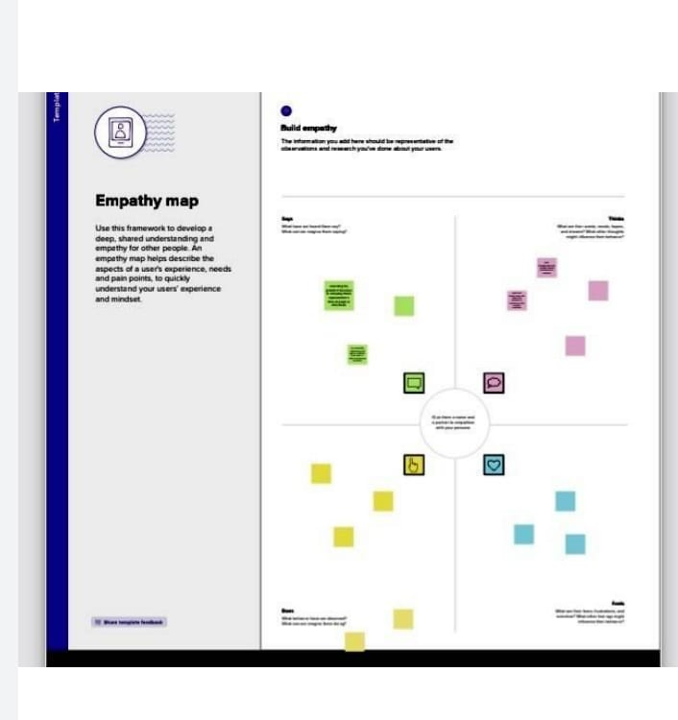

**2.2 Ideation and brainstorming map:**

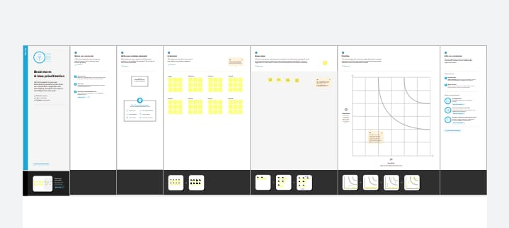

**3.Result:**

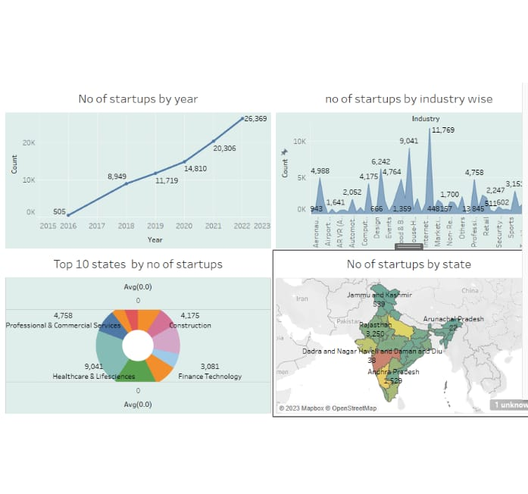

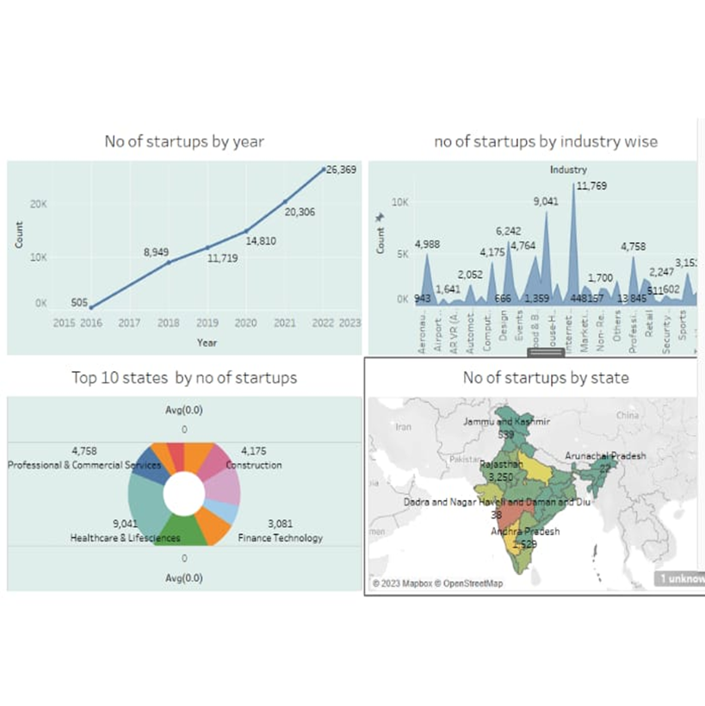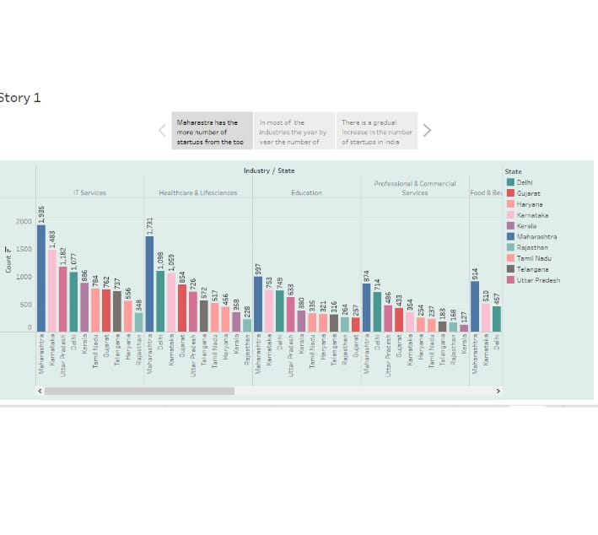

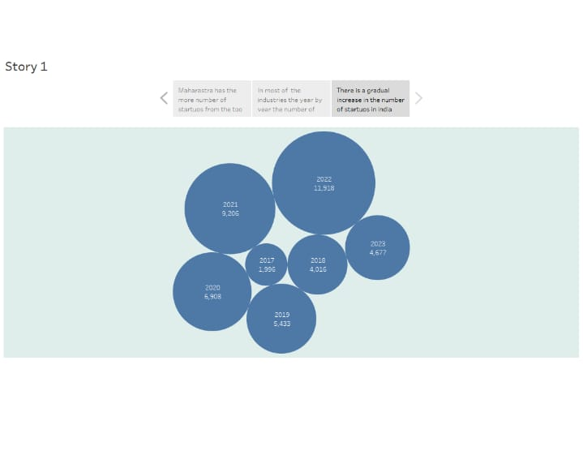

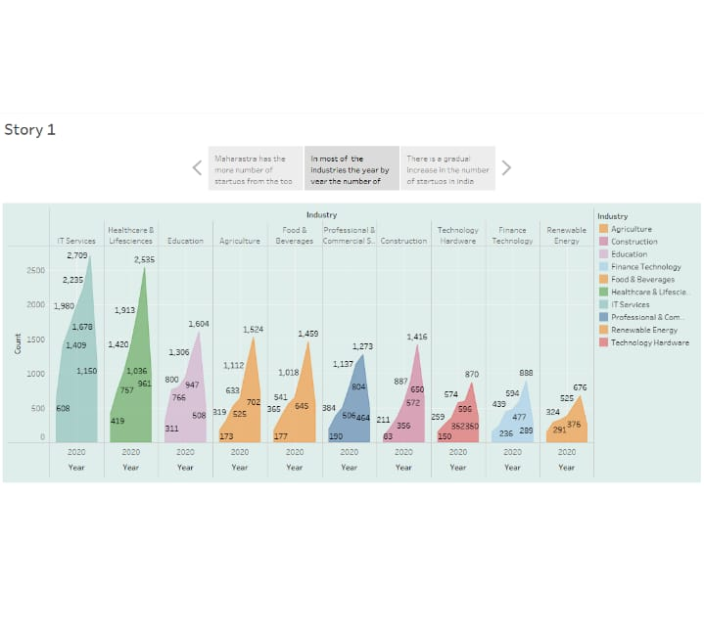

**4.Advantages & Disadvantages:**

**Advantages of startup analysis:**

* **Agility**
* **Efficiency**
* **Teamculture**
* **Personalisation**
* **Versatality**
* **Flexibility**
* **Having fun**

**Disadvantages of startup analysis:**

* **Risk of failure**
* **Low compensation**
* **Poor market access**
* **Team conflicts**
* **Lack of resource**
* **Lack of process**
* **Stressed out**

**5.Applications**

Examples of implementing Big Data - Currently, many people can access the internet from smartphones, tablets or other devices so that this results in a large amount of data. So don't be surprised if currently using Big Data is an investment capital for business companies.

Big Data is described by a large volume of data, both structured and unstructured data. Much of the value of this large company comes from data that is continuously analyzed with the aim of being able to offer better service to serve its customers. The analysis carried out also aims to develop products and produce new features.

**6.Conclusion**

Startups are one of the most promising ways to solve the critical problems humanity is facing because they can react much faster to problems that arise and can innovate solutions more freely than traditional corporations. The startup ecosystem, in turn, enables the prototyping and market testing of a massive number of new potential innovations, accelerating the progress through which pressing global issues can be solved.

7.Future scope:

1. **Robotics:** There is an enormous level of new interactions that are in store between people and machines.
2. **Transportation tech:** There are a number of self-driving startups already. We will come to a point where the cars will become like PCs - where the hardware becomes less important/commoditized and there will be a host of software players who will help run the system & add features.
3. **Energy tech:**As solar becomes cheaper than conventional fuels, it will take over the grids everywhere. That will require smart load balancing, better battery technologies.
4. **Space tech:**With nanosatellites able to be built by anyone and low orbit rockets launched by private companies, we will come to a point where there will be a number of tiny SpaceX all building equipments for the new space race. Over 100 countries will wait for their services to get them to space.
5. **Health tech:**There is already some tech in healthcare, but it is a sector that has evaded big transformation and the regulations have aided that. Over the next 10 years, there will be new challenges imposed due to rapidly greying population and bankrupt governments will be forced to open up this sector to automation.